**AI ASSISTED CODING**

NAME: SHARIKHA IMTIAZ KHAN

ROLLNO:2403A52368

TASK 1: Write python function to return sum of even and odd numbers in the given list

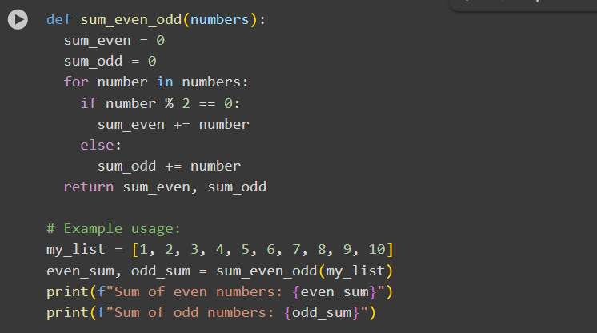

EXPLANATION:

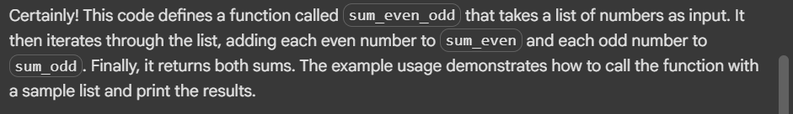

OUTPUT:

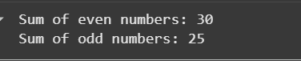

TASK2:  Write python program for sru_student class with attributes like name, roll no., hostel_status and fee_update method and display_details method

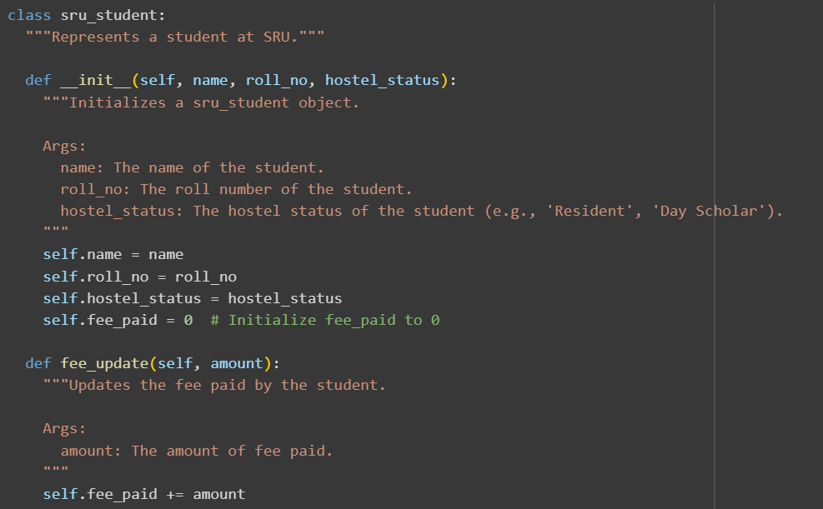

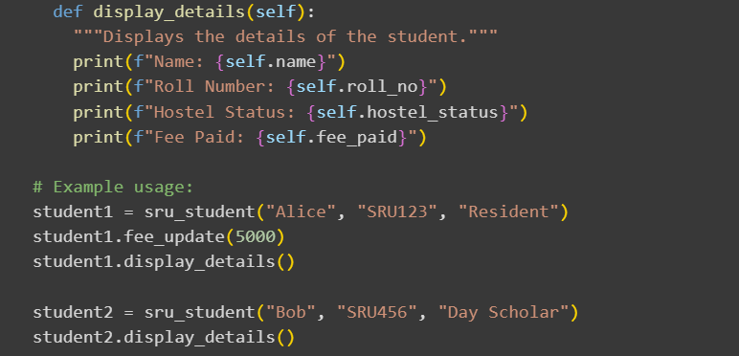

EXPLANATION:

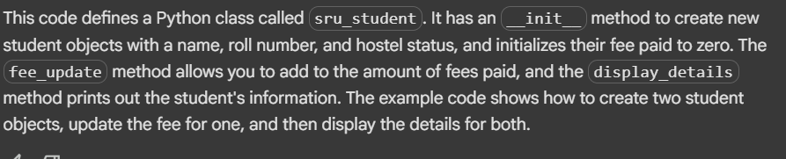

OUTPUT:

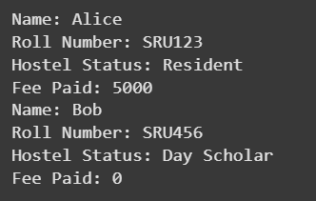

TASK3:  Write a Python script with 3–4 functions (e.g., calculator: add, subtract, multiply, divide)

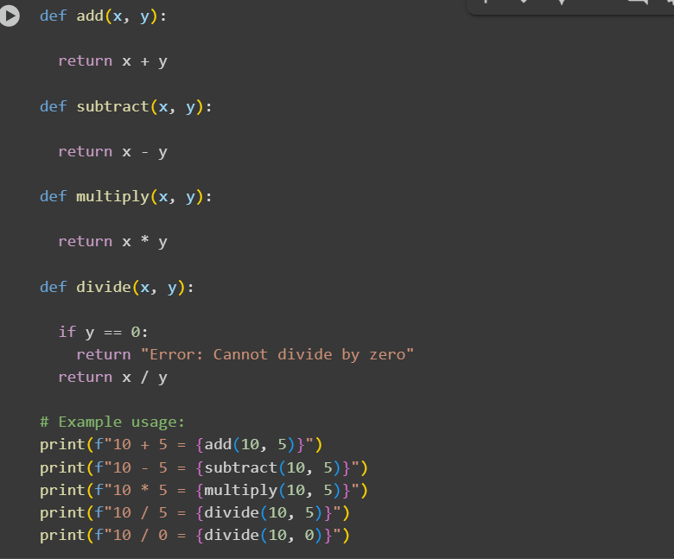

EXPLANATION:

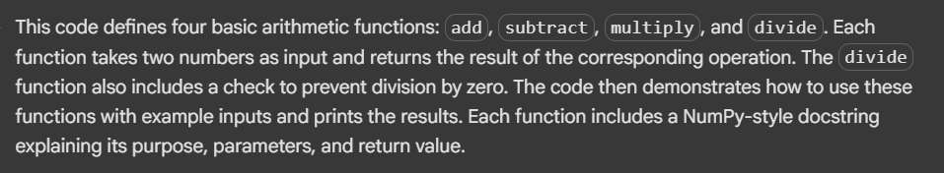

OUTPUT:

